SANDS

**A 3D Time-Bending Puzzle GamE..……………………………..**

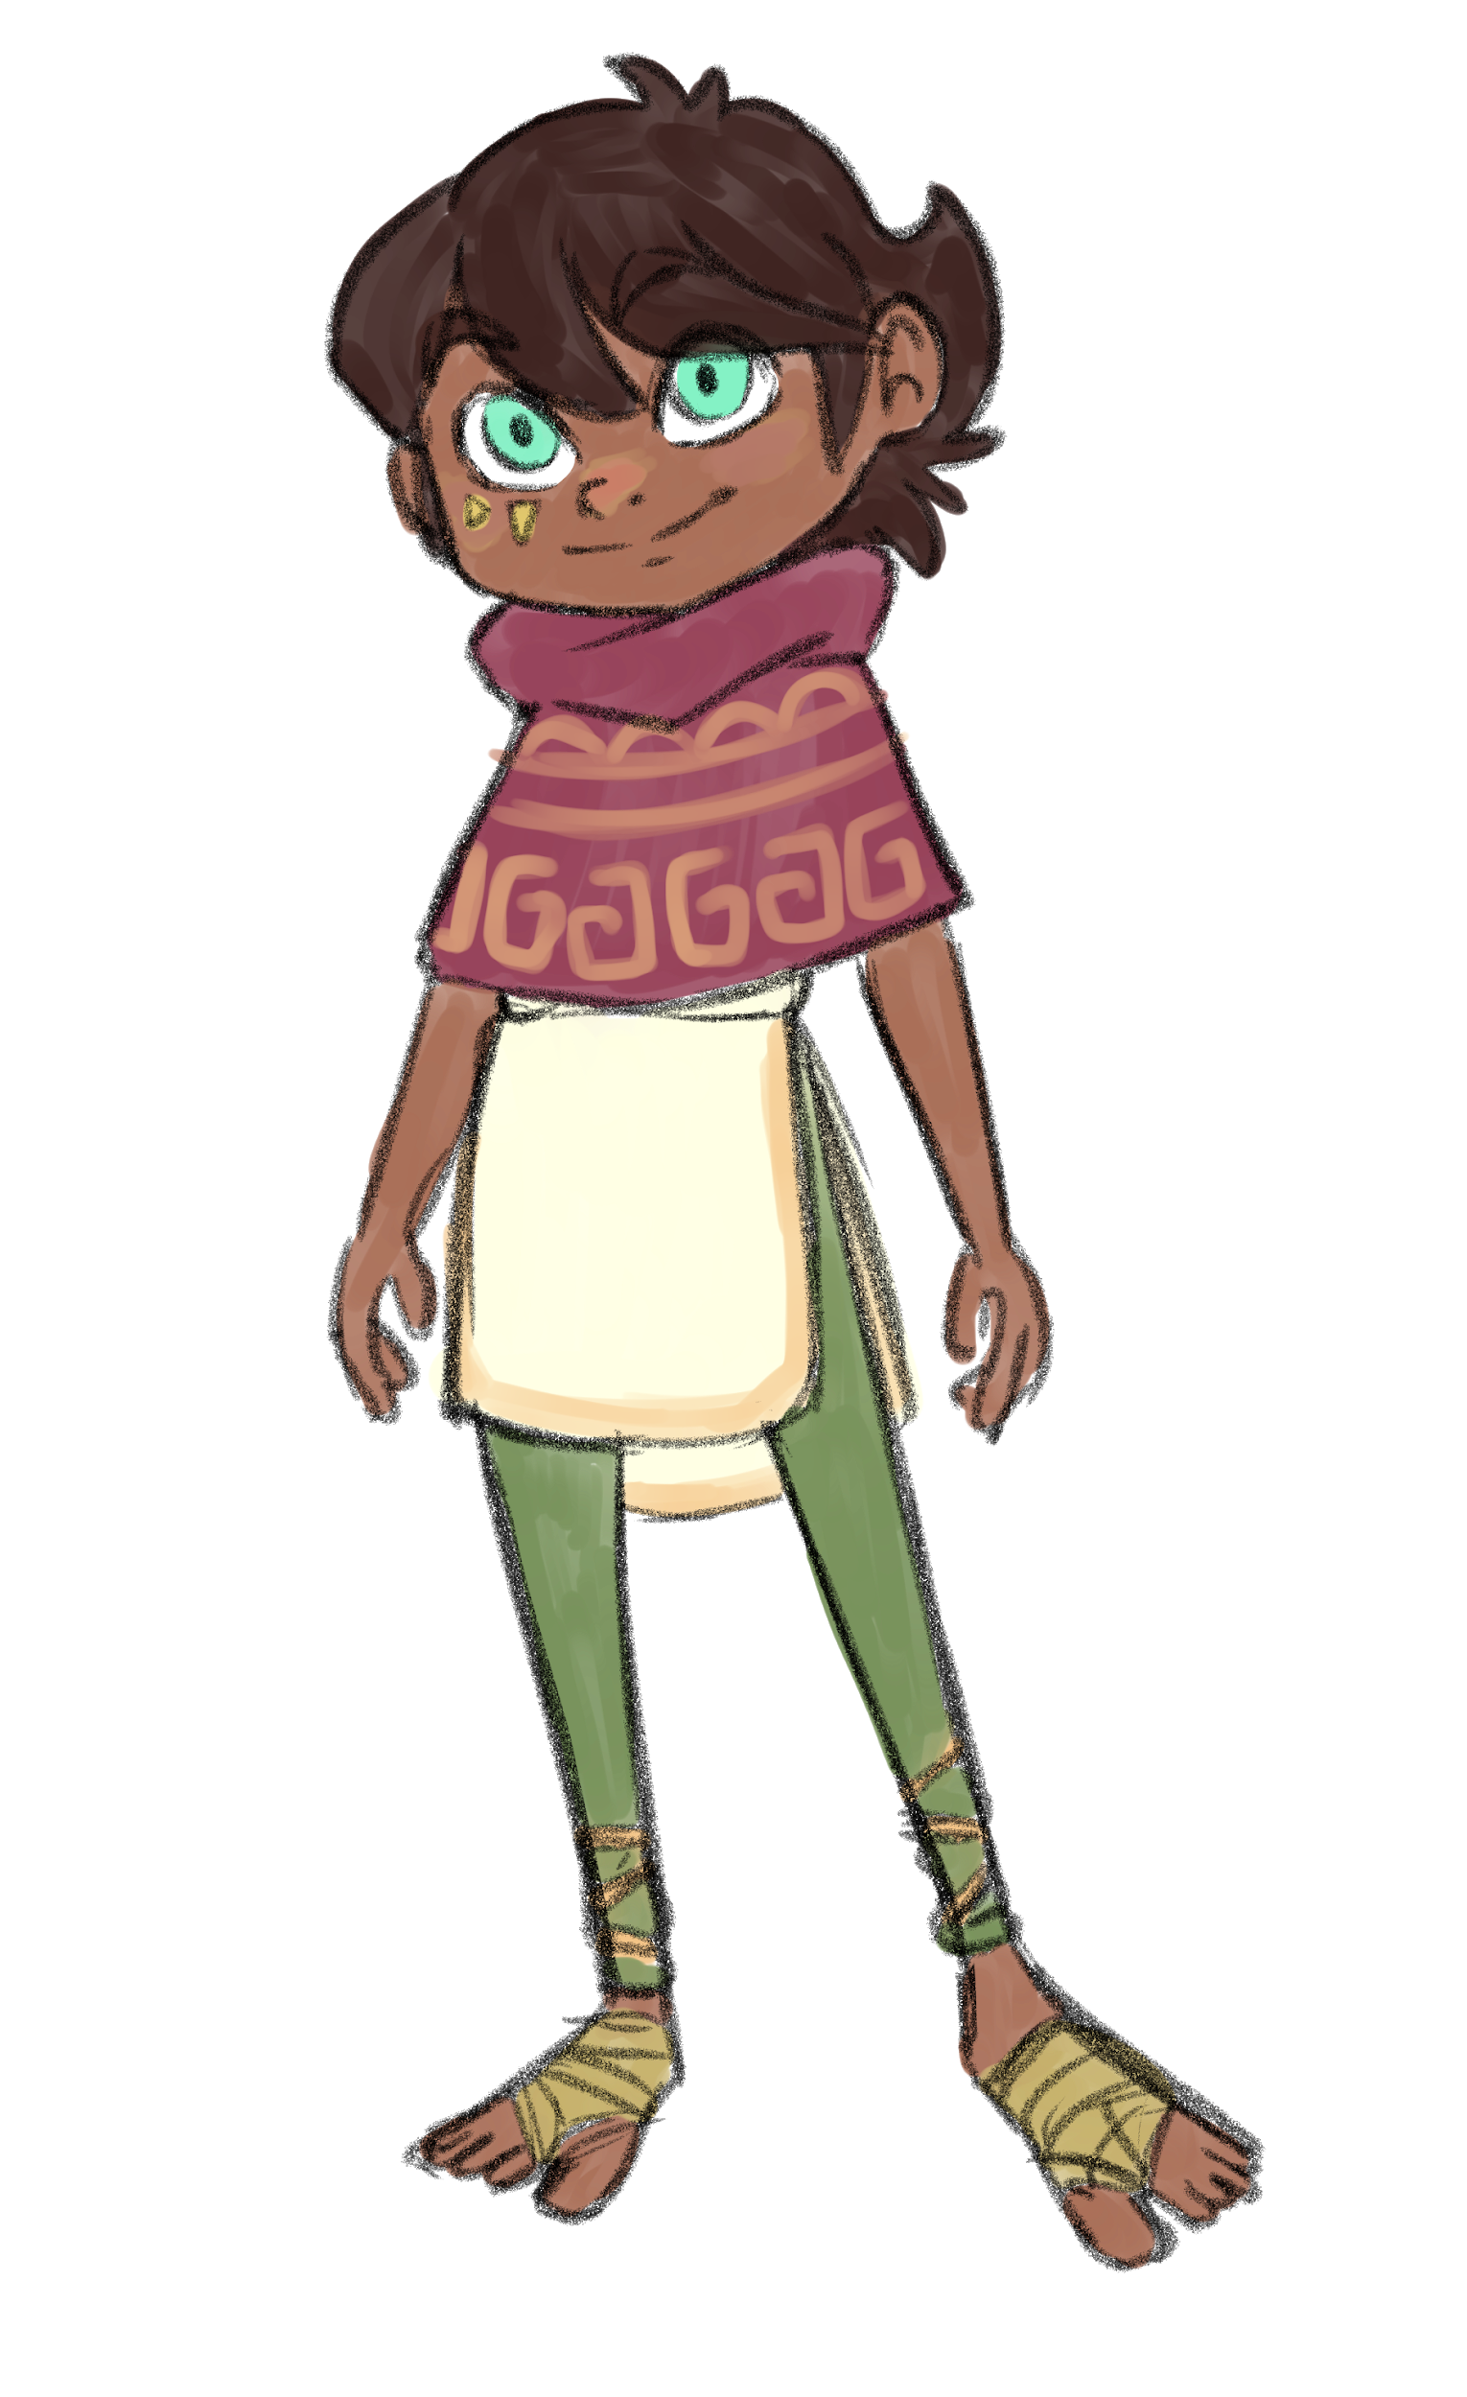



Elena Todorovska

Project Director



Jess Bailer

Art Director



Caitlin Hendricks

2D & 3D Artist



Raushon Henry

Software Developer



Tessa Costley

Developer



Paul Ethridge

3D Artist



Overview

Overall Concept

Objective

Theme / Setting / Genre

Win / Lose Conditions

Core Gameplay Mechanics

Targeted platforms

Targeted audience

Project Scope

Influences

The Elevator Pitch

What sets this project apart?

Story and Gameplay

Story

Gameplay (Brief)

Controls

Gameplay (Detailed)

Core Gameplay Mechanics

Character

Look

Background

Abilities

Environment

Appearance

Camera

Lighting

Dynamics

Time Glitches

Time Beads

Level Design/World Design

The Temple of the Timekeeper

Tutorial Chambers

Puzzle Chambers

UI Design/ HUD Design

Assets Needed

Schedule

Prototype Schedule

Alpha Schedule

Beta Schedule

Publication Schedule

# Overview

## Overall Concept

* The story reveals that the mystical timekeeper totem has been stolen from the sacred Temple of the Timekeeper. Chaos has struck and shaken the delicate fibers of the time space continuum. Your player character must solve puzzle platformer chambers within the temple to restore the timekeeper totem to its rightful place and thus restoring balance to the universe.

## Objective

* The Temple of the Timekeeper contains many puzzle chambers leading to its most sacred pedestal chamber. The mystical timekeeper totem must be utilized to traverse the chambers within the temple before finally placing it to rest on the pedestal where it belongs.

## Theme / Setting / Genre

* Time Bending 3D Puzzle Platformer
* The Temple of the Timekeeper resides in the far reaches of the desert.

## Win / Lose Conditions

* The player wins the game once the mystical timekeeper totem has been returned to the sacred pedestal, which means every puzzle chamber and puzzle door has been solved.
* You cannot lose the game. Unless you played in marching band.

## Core Gameplay Mechanics

* Time Bending
* Puzzle Chamber Manipulation
* Resource Management (Time Beads)
* Minigame Puzzle Doors

## Targeted platforms

* PC
* Mac

## Targeted audience

* Everyone

## Project Scope

* 12 - 13 Weeks
* 6 Team Members
* Team (Continued)
  + Elena Todorovska - Project Director
    - Software Developer
    - Level Design
  + Jess Bailer - Art Director
    - 2D & 3D Assets
    - Digital Paintings
    - Cinematics
  + Caitlin Hendricks - Technical Director
    - 3D Assets
    - 2D Assets (Vector Graphics)
  + Raushon Henry - Software Developer
    - Cinematics
  + Tessa Costley - Developer & Artist
    - 2D Assets
    - Level Design
  + Paul Ethridge - Artist
    - 3D Assets (Hard Surface)

## Influences

* Journey
  + Video Game
  + Aesthetic Value
* ClueFinders (4th Grade)
  + PC Educational Game
  + Puzzle Solving and History Themes
* Ratchet & Clank Future: A Crack In Time
  + PS3 Game
  + Time Mechanic
* Okami
  + Wii / Switch Game
  + Resource Management, The Ink

## The Elevator Pitch

* Sands is a unique mix of platforming and puzzle solving with clever environmental manipulation mechanics that engage and immerse the player in the game progression.

# What sets this project apart?

* Unique combination of puzzle platformer and mini-game puzzles
* Charming character design
* Application and versatility of gameplay mechanics

# Story and Gameplay

## Story

* The player character’s friend, fueled by curiosity and clouded by ignorance, has wandered into the Temple of the Timekeeper and taken with them the mystical timekeeper totem. With the totem removed from it's home chaos has swiftly struck and shaken the delicate fibers of the time space continuum.
* The player character, on their way to visit their friend, finds their friend’s home disheveled but otherwise seemingly empty. At the writing desk in the corner is a pile of clothes, a shimmering hourglass and a partially written note. Hidden within the pile of clothing is a small child that looks very much like your friend. What a conundrum! The player then reads the note and realizes that the child at the writing desk is indeed their friend regressed in time! This knowledge, along with the note, drive you to venture out to repair the damage your friend has done by finding the Temple of the Timekeeper.
* As you leave your home on your journey to return the timekeeper totem, you notice strange things happening all around you. Crops are shrinking back into seedlings and water is beginning to flow the wrong way. As the Temple comes into view you see a strange discolored rift in the sky near the top of the temple. Could this be causing the chaos in your village?
* Your player character must solve puzzle platformer chambers within the temple to restore the timekeeper totem to its rightful place and thus restoring balance to the universe. Using your agility and wit, adventure through the temple to reach the top in order to save your friend, your village, and all of time!

## Gameplay (Brief)

* The player will navigate through three levels of a temple in order to return the timekeeper totem to its home at the top. Levels will be solved using a combination of platforming and puzzle-solving to unlock each new level. The difficulty of the levels increase as the player gets closer to the goal.

## Controls

* Primary controls are via keyboard and mouse
* Movement
  + WASD
  + Space to Jump
* Actions
  + Left Click
    - Select objects to manipulate
    - Select menu options
  + Scroll Wheel
    - Select a game mechanic

## Gameplay (Detailed)

* Title / Splash Screen
  + Title Card loads
  + Player can click “Start” to load Main Menu
* Main Menu
  + Player can click one of several menu options
  + New Game
  + Continue Game
  + Options
  + Credits
  + Exit
* At any time during gameplay the player may open the following menus
  + Pause menu
    - Allows for save and exit
    - Allows for quit without saving
  + Journal Menu
    - Help Page
      * Shows you controls
      * Lets you review the game mechanics
    - Story Page
      * Shows you what story you’ve discovered so far
* Introductory Cutscene Plays
* Temple Cutscene Plays
* Player walks through map chamber for level 1
* Player enters first tutorial chamber
  + Player is introduced to game mechanics
    - Freeze Time & Slow Time
  + Player reaches chamber exit
  + Player is introduced to puzzle door mechanic
    - Picture Slider
  + Player solves puzzle door
* Player enters second tutorial chamber
  + Player is introduced to game mechanics
    - Glitched Objects
    - puzzle chamber Manipulation
    - Time Beads
  + Player reaches chamber exit
  + Player is introduced to puzzle door mechanic
    - Memory Match
  + Player solves puzzle door
* Player enters first easy chamber
  + Player solves and exits the chamber
* Player walks through map chamber for level 2
* First progress cutscene plays
* Player enters first medium chamber
  + Player solves and exits the chamber
* Player walks through map chamber for level 3
* Second progress cutscene plays
* Player enters first hard chamber
  + Player solves and exits the chamber
* Third progress cutscene plays
* Player reaches final chamber puzzle door
  + Player solves the puzzle door
* Final progress cutscene plays
* Player enters pedestal chamber and approaches pedestal
* Totem return cutscene plays
* End Game cutscene plays
* Gameplay stats displayed in end title card
* Credits roll

## Core Gameplay Mechanics

* Time Bending
  + Time manipulation will be the key mechanic to solving a majority of the puzzle chambers.
  + Stopping Time
  + Stopping Time (continued)
    - This mechanic allows the player to momentarily stop a moving object (or objects) in the current puzzle chamber. As well as put into motion previously stopped objects.
    - The player selects the [symbol] on the mystic timekeeper and clicks on the object they wish to still or put back into motion. The object will immediately freeze or move when the mouse button is released.
  + Slowing Time
    - This mechanic allows the player to momentarily slow a moving object (or objects) in the current puzzle chamber.
    - The player selects the [symbol] on the mystic timekeeper and clicks on the object they wish to slow down. The object will slow to quarter speed when the mouse button is released.
* Puzzle Chamber Manipulation
  + The orientation of the puzzle chamber may not be consistent between chambers as time and reality are warping. This will occasionally need to combine with the time bending mechanics to solve the puzzle(s).
  + Spinning
    - This mechanic allows the player to rotate the chamber 90 degrees horizontally.
    - The player selects the [symbol] on the mystic timekeeper and clicks on either the left wall (to rotate -90 degrees) or the right wall (to rotate +90 degrees). The puzzle chamber will rotate horizontally in that direction, adjusting your view of the chamber as well as the puzzle components within the chamber.
  + Flipping
    - This mechanic allows the player to rotate the chamber 90 degrees vertically.
    - The player selects the [symbol] on the mystic timekeeper and clicks on either the ceiling (to rotate -90 degrees) or the floor (to rotate +90 degrees). The puzzle chamber will rotate vertically in that direction, adjusting your view of the chamber as well as the puzzle components within the chamber.
* Resource Management (Time Beads)
  + Each level begins with a set number of Time Beads(Tries), time sand compressed into beads contained in the timekeeper totem (hourglass).
  + Each manipulation of time costs a Time Bead, shown in the UI. If the player runs out of Time Beads the level will rewind and start over.
* Minigame Puzzle Doors
  + Each puzzle chamber exit is locked with puzzle doors. The puzzle on the door must be completed to move on to the next puzzle chamber.
    - Picture Slider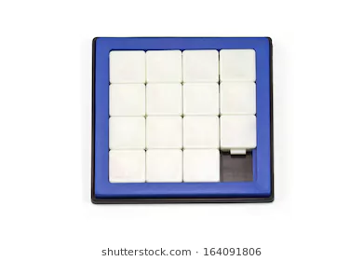
      * An image is split into 4 x 4 squares. The squares are shuffled with one square empty. The squares must be moved to rebuild the image.
    - Memory Match
      * Glyphs are displayed in 4 x 4 squares. The glyphs disappear after a time. The player must select squares to find two matching glyphs. When all the matches are found the puzzle is solved.

# Character

## Look

* Young, child-like features with deep, tan skin tone.
* Bright piercing eyes.
* Tousled hair, short or pulled back.
* Linen clothing with shawl for protection from the elements.
* No shoes, only wraps around portions of the feet to cushion and protect them.
* Gender is intended to be unknown since the player is given the choice of naming the character. Player can project any gender they choose upon the character.
* *See Title Page Image*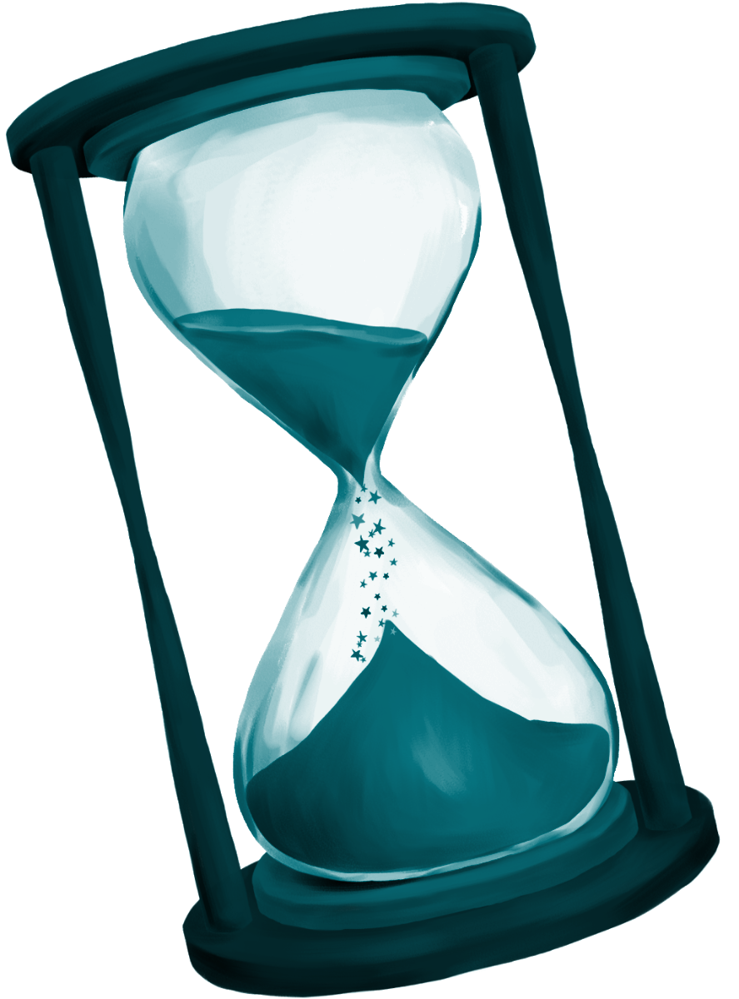

## Background

* Quiet and reserved child living with her family. Works in her father’s market stand selling produce and fine silks to people of the city.
* Not the typical hero type and tends to stay out of trouble.
* Lives a simple and humble life.

## Abilities

* Main character will have time manipulation abilities. This includes but is not limited to: pausing time, slowing down time, and rotating chambers.

# Environment

## Appearance

* Majority of the environments consist of Persian/Egyptian inspired architecture, sand, and desert elements. Occasional elements from different time periods such as Chinese, Mayan, and Aztec will be seen around the environment as evidence to the player that time is glitching and falling apart.
* The player will be able to manipulate certain elements of the environment, including but not limited to pillars, doors, and other structures.

## Camera

* Fixed 3rd person perspective similar to an isometric game.

## Lighting

* Soft interior environments with warm lights overall, hints of blues and cooler tones to denote elements involving time and time manipulation.

# Dynamics

## Time Glitches

* Environment will be changing based on the progression throughout the levels due to the time glitches.
  + Misplaced items from different eras will be present throughout the temple’s puzzle chambers. Each level of the temple will contain more misplaced items than the last.
* When a fail state is reached (see Time Beads) time rewinds and the puzzle chamber is reset.

## Time Beads

* Move / Try Count
* The player has limited attempts to use the mechanics to solve the puzzle chamber.
* When the try count is exceeded the time glitch rewinds the puzzle chamber and resets the try count.
* From a lore / storyline standpoint we are calling these tries “Time Beads”

# 

# Level Design/World Design

## The Temple of the Timekeeper

* 3 tier system
  + Level 1 - Easy puzzles
  + Level 2 - Medium puzzles
  + Level 3 - Hard puzzles
* Map Chambers - show the player their thus far temple / chamber progress
* Pedestal Chamber - final chamber for cutscene & story purposes only chamber to contain no puzzles at all.
* Each puzzle chamber has a door you entered in from (closes behind you, cannot go in reverse) as well as a door you must reach to exit with.
* The mechanics must be used to reach the exit door for the chamber.
* The exit door is locked with a mini game puzzle.
* After each tier of the temple is complete you will encounter a map chamber.

## Tutorial Chambers

* 2 tutorial chambers will introduce the player to the game mechanics
* Tutorial Chamber 01
  + Freeze Time
  + Slow Time
* Tutorial 01 Exit Door
  + Picture Slider Mini Game Puzzle
* Tutorial Chamber 02
  + Glitched Objects
  + puzzle chamber Manipulation
  + Time Beads
* Tutorial 02 Exit Door
  + Memory Match Mini Game Puzzle

## Puzzle Chambers

* Easy Chamber 01
* Medium Chamber 01
* Hard Chamber 01

# UI Design/ HUD Design

* Title / Splash Screen
  + SANDS displayed
  + Player can hold ‘Enter” to load Main Menu
* Main Menu
  + New Game - starts gameplay, overwrites save slot
  + Continue Game - renews gameplay, using existing save slot
  + Options - turn on hints, etc.
  + Credits - run credit reel
  + Exit - quit the game
* Pause menu
  + Temporary pause gameplay
* Journal Menu
  + Help Page - display tutorial pages, mechanic info, UI info
  + Story Page - display currently known story elements
  + Save and Exit - ask for save slot
  + Quit without saving

# Assets Needed

* **2D**
  + Textures
    - Environment Textures
      * Sand
      * Wall Embellishment
        + Glyphs & Cracks
    - Map for Map chamber
      * Levels 1, 2 and 3
  + UI Graphics
    - Hourglass Bead Count (Side View)
      * Full & Empty
      * Individuals Missing
    - Hourglass Beads
    - Hourglass Selector (Top View)
    - Journal
      * Help Page(s)
      * Story Page(s)
    - Title / Splash Screen
    - Main Menu
    - Pause Menu
* **3D**
  + Characters List
    - Main/Player Character
    - Character’s Companion
  + Environmental Set Pieces
    - Walls
    - Torches
    - Sand Piles
    - Pillars (Broken & Intact)
    - Stone Blocks
    - Sand Columns
    - Era Specific
      * Chinese Lantern
      * Chinese Dragon
      * Egyptian Scarab
      * Egyptian Sarcophagus
      * Golden Idol
      * Olmec Head
* [**Sound**](https://drive.google.com/a/uah.edu/open?id=1ANEMNYLW0d5mKUQKrK7K5vmTikx2AJA1QvEe-Yu2H7s)
  + Music
    - Cutscenes
    - Ambient
    - Menus
  + Foley
    - Key Mechanics
    - Character Movement
    - Menu Option / Pull up Journal
* **Animation**
  + Environment Animations
    - Ambient occurrences (Walls shaking, dust falling from ceiling)
  + Character Animations
    - Player
    - Companion
  + Puzzle Object Animations
    - Pillars Moving
    - Shifting Columns
    - Falling Blocks

# Schedule

* Week 1
  + Intro & Surveys
* Week 2
  + Game Pitches
* Week 3
  + Game Teams & Vision Board
* Week 4
  + GDD & Prototype Phase Goals
* Week 5
  + Prototype Phase
* Week 6
  + Prototype Phase
* Week 7
  + Prototype Phase Due & Alpha Phase Goals
* Week 8
  + Alpha Phase
* Week 9
  + Alpha Phase
* Week 10
  + Alpha Phase
* Week 11
  + Alpha Phase
* Week 12
  + Alpha Phase Due & Beta Phase Goals
* Week 13
  + Beta Phase
* Week 14
  + Beta Phase
* Week 15
  + Beta Phase Due
* Week 16
  + Bug Fix & Publication Prep
* Final
  + Publication & Submission

# 

## Prototype Schedule

* [Submitted Milestone Goals](https://drive.google.com/open?id=1ETKeGWfwsCBfGjfFPFqCHcXf5p76gaSoWHFisXF9CS4)
* Week 4 - Prototype Phase
  + Tuesday Sept 4 - Vision Board
  + Tuesday Sept 4 - Tutorial Level & 3 Tier Pyramid Design
  + Thursday Sept 6 - GDD & Prototype Phase Goals
  + Thursday Sept 6 - Asset Priority List
* Week 5 - Prototype Phase
  + Splash / Title Screen
  + Main Loading Menu
  + Map Chamber
* Week 6 - Prototype Phase
  + Tutorial Chamber designs
* Week 7 - Prototype Phase
  + Prototype Phase Due & Alpha Phase Goals

## Alpha Schedule

* *Not Submitted Yet Milestone Goals*
* Week 8 - Alpha Phase
* Week 9 - Alpha Phase
* Week 10 - Alpha Phase
* Week 11 - Alpha Phase
* Week 12 - Alpha Phase
  + Alpha Phase Due & Beta Phase Goals

## Beta Schedule

* *Not Submitted Yet Milestone Goals*
* Week 13 - Beta Phase
* Week 14 - Beta Phase
* Week 15 - Beta Phase
  + Beta Phase Due

## Publication Schedule

* Week 16 - Publication Phase
  + Bug Fix & Publication Prep
* Final - Publication Phase
  + Publication & Submission